P250/2

**GEOGRAPHY**

Paper 2

**Jul / Aug. 2022**

3 hours

**MARKING GUIDE**



**Uganda Advanced Certificate of Education**

GEOGRAPHY

**Paper 2**

2 hours

**SECTION A : FIELD WORK**

**IMPRESSIONAL MARKING**

**0 - 06** Hopeless Answer

07 - 09 - ‘O’ level answer

10 - 12 - Marginal answer

13 - Basic ‘A’ level Answer

14 - 16 - Average answer

17 - 19 - Good answer

20 - 22 - Very good answer

23 - 25 - Excellent Answer

**SECTION A**

1. (a)

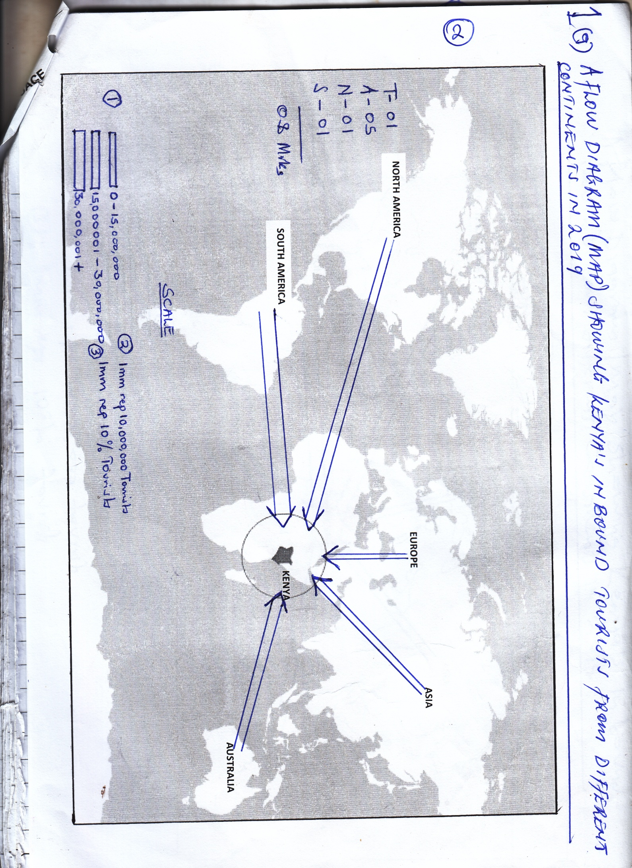

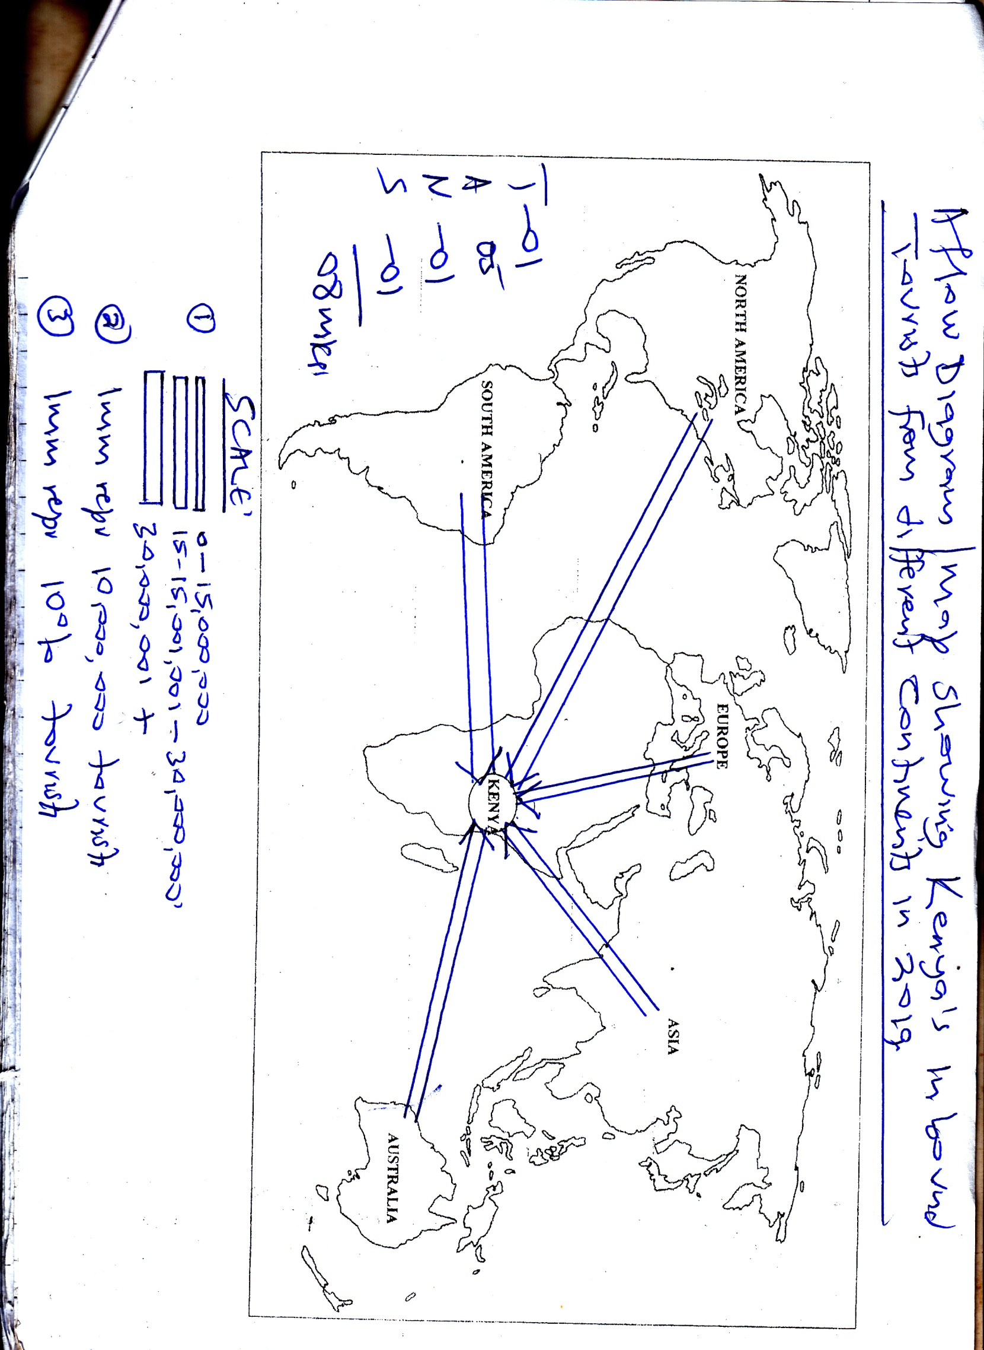

1. **Demerits of the method**

* Occupies large space
* Drawing consumes time
* Difficult to get the scale because of large amplitude
* Involves a lot of calculations
* Difficult to tell the actual values
* Maintaining the site of arrows is difficult
* Many arrows makes the map congested and thus difficult to interpret.

**Maximum 03**

( c) Comments

* 24,600,000 came from Asia
* 12,900,000 tourists came from Europe
* 30,900,000 tourists came from Australia
* 41,600,000 tourists came from South America
* The total number of impound tourists is 134,000,000
* The highest number of tourists came from Australia followed by South America followed by North America, followed by Asia and lastly Europe

NB: Accept any relevant comment

**Max 04**

(d) Impact of the inbound tourism on the environment of Kenya

**Positive impact**

* Generation of revenue
* Generation of foreign exchange
* Promotes development of urban centres / towns / cities
* Promotes international trade and relatives
* Development of transport networks
* Development of social services
* Leads to the acquisition of skills
* Promotes conservation of the tourists assets
* Provides employment opportunities
* Diversification of the economy
* Promotes the development of hotal industry
* Provides market for other sectors
* Attracts foreign investments
* Promotes education and research
* Advertises local resources abroad.

**Maximum = 06 marks**

**Negative impact**

* Importation of foreign cultures which are bad
* Promotes environmental degradation
* Promotes poaching and smuggling of valuable animals
* Urban related problems
* Displacement of agriculture and settlement
* Promotes capital repatriation
* Promotes regional imbalance
* Destruction of the landscape due to hotel sprawl
* Easy spread of contagious diseases
* Promotes hiking of prices of local products
* Associated with accidents

**Maximum = 04 marks = 08 marks**

**SECTION B**

1. **Explain the conditions for the increased normadic pastoralism in Sahel region of Africa.**

* Candidates should define normadic pastoralism
* Identify the countries in the Sahel region e.g. Senegal, Mauritania, Mali, Bukinafaso, Niger, Nigeria, Chad and Sudan
* Should identify the normads in the region e.g. Fulani, Dinka, Tuaregs, Berbers etc
* They should explain the conditions for the increased normadic pastoralism.
* Presence of unreliable rainfall and hot temperatures
* Presence of infertile soils which affect the quality of the pastures
* Poorly developed infrastructures in form of roads
* Communal land ownership in the region
* Presence of poor pastures forestry and normads to move
* High incidence of animal pests and diseases
* They keep local breeds which are resistant to drought e.g. Zebu, White Fulani cattle, Sanga, Solcote red goats etc
* Cultural and traditional tendencies
* Unfavourabl government policies
* The normads here are very hostile
* Presence of extensive land for the movement of animals
* Presence of flat relief for the easy movement of the animals
* The normads do not recognize political boundaries
* The influence of sparse population reducing on competition for land
* They keep large herds of cattle for insurance
* Absence of surface water
* Illiteracy / low levels of education
* Limited competition with crop growers etc

**(25 marks) Impressional marking**

1. **Examine the problems faced by the agricultural sector in south East Asia.**

* Candidates should define agriculture and identify the agricultural systems in this region
* Countries in south east Asia, include, Indonesia, Myanmar, Singapore, Thailand, Vietnam, Cambodia, Malaysia, Phillipineseetc

The agricultural systems here include:-

* Irrigation farming
* Growing of cerreals e.g. rice
* Mixed farming
* Plantation farming
* Shifting cultivation
* Intensive farming
* Dry farming etc

The problems include the following:-

* Pests and diseases which reduce on the quality of crops and animals
* Harsh climatic conditions e.g. floods, huricanes strong winds, drought
* Mountainous nature / rugid topography which limit mechanization
* Infertile soils
* Presence of wild animals which destroy the farmers crops and farmers
* Poor drainage effect the quality of the crops
* Soil exhaustion
* Inadequate capital for investments
* Poor disposal of masters / pollution
* Unfavorable government policies e.g. over taxation
* Poor transport network or remoteness
* Competition for market with other countries
* Poor animal breeds and crop varieties
* Low levels of technology in the agricultural sector
* Poor shortage facilities
* Price fluctuations which affect the profit margins
* Inadequate capital for investments
* High costs of land
* Political instabilities which scare away investors
* Dense populations limiting land for agricultural development
* High rates of rural urban migration
* Cultural and religious attitudes
* Limited research in the agricultural sector

Etc

**25 marks (impressional marking)**

1. **Explain the consequences of rampant forest destruction in any one country in the Amazon basin.**

Candidates should define a forest.

Identify one country from the Amazon basin e.g. Brazil, Bolivia, Peru, Equador,

Colombia, Venezuela, French Guiana, Guyana Suriname.

Candidates should mention the major characteristics of the forest and the true species.

**Consequences**

* Loss of valuable true species
* Increased pollution with associated problems
* Siltation of rivers and lakes
* Increased flooding with associated problems
* Promotes leaching with associated problems
* Promotes landslides which destroys lives and properties
* Leads to energy crisis
* Leads to wind forms storms which destroy lives and properties
* Displacement of the indigenous communities e.g. the red Indians, Witoto, Boro, Arua, Kayapoetc
* Loss or decline in government of revenue
* Loss of employment of the level people
* Promotes soil erosion
* Rapid loss of soil fertility
* Promotes aridity and desertification
* Lowering of the water table affecting the water cycle
* Destruction of the natural habitants of the wild animals affecting the tourism industry. Etc.

**(25 marks) Impression marking**

1. **To what extent have the human factors influenced the development of the fishing industry in either Sweden or Namibia?**

Candidates should define fishing select one country, identify the fishing ground, fish species, the fishing methods and the fishing ports.

**Explain the factors influencing the development of fishing.**

**Human factors**

* Presence of large market for fish
* Presence of adequate capital for investment
* Efficient transport network
* Presence of advanced technology
* Presence of efficient cooperative organization’s
* Influence of religious factors
* The sea fearing tradition of the people
* Presence of large supplies of labour
* Intensive research
* The favourable government policies
* Presence of advanced processing and storage facilities
* Relative political stability for long term investment
* Presence of large supplies of power and energy.
* Presence of numerous industries which manufacture fishing gears e.g. hooks, nets
* Presence of advanced fishing methodoly and trawling’s.

**Physical factors**

* The mountainous nature of the country (Sweden)
* Presence of infertile soils for agriculture
* Presence of a variety of fish species of commercial values
* Presence of indented coasts
* Influence of ocean currents e.g. warm atlantic drift (Sweden), cold banguela (Namibiga)
* Presence of large fishing grounds
* The smooth ocean floor
* Presence of numerous rivers
* Abundant supply of planktons
* Presence of extensive and shallow continental shelf.
* Influence of climate e.g. cool clomate (Sweden)
* Dry conditions (Namibia)
* Presence of extensive forests and forests products for boat making
* Limited economic activity
* Presence of numerous off shore islands
* Etc

**25 marks Impressional marking**

1. **Account for the rural settlement distribution in Africa.**

Candidates should define rural settlement and identify areas of dense and areas of sparse rural settlements in Africa.

The factors for rural settlement distribution include the following:-

**Physical factors**

* Variations in relief
* Variations in drainage
* Variations in soil fertility
* Variations in climate
* Differences in vegetation distribution
* Influence of pests and diseases
* Influence of wild animals
* Strategic location along the coast.

**Human factors**

* Differences in employment opportunities
* Differences in transport distribution
* Influence of political climate

Historical factors

* Variation in government policies
* Cultural, religious factors
* Influence of natural hazards
* Variation in trade and commerce.
* Etc

**25 marks Impression marking**

1. **To what extent have the physical factors hindered the effective utilization of inland water transport in sub Saharan Africa?**

* Candidates should define water transport
* Identify the types of water transport with their examples e.g. lakes, rivers, and canals
* Explain the factors hindering the use

**Physical factors**

* Presence of waterfalls, rapids and cataracts
* Presence of narrow river vallies
* Some lakes are shallow
* Fluctuations of volumes of water in lakes and rivers
* Presence of floating vegetation
* The steep sided valleys and banks of rift valley lakes (graben)
* Presence of swamp and swamp vegetation. Silting of rivers
* Presence of fast flowing rivers from the highland areas.
* Presence of predators which destroy lives and property
* Absence of land water bodies in some countries
* Presence of strong winds storms of rivers and lakes.
* Presence of rock outcrops / rough bed
* Meandering of some rivers
* Presence of braiding of rivers.

**HUMAN FACTORS**

* Inadequate capital for investments
* Low levels of economic development in the immediate hinterland
* Absconded of political operation between / among countries that shares water body
* Unfavorable government policies.
* Competition from other faster means of transport
* Limited research
* Inadequate skilled labour to manage the sector
* Piracy with associated problems
* Presence of outdated technology
* Political instabilities which destroy lives and properties.
* Accidents
* Etc

**25 marks Impressional marking**